www.webassign.net
Username: lastnamefirstname ex) smithjohn
Institution: bhs.ut
Password: student number
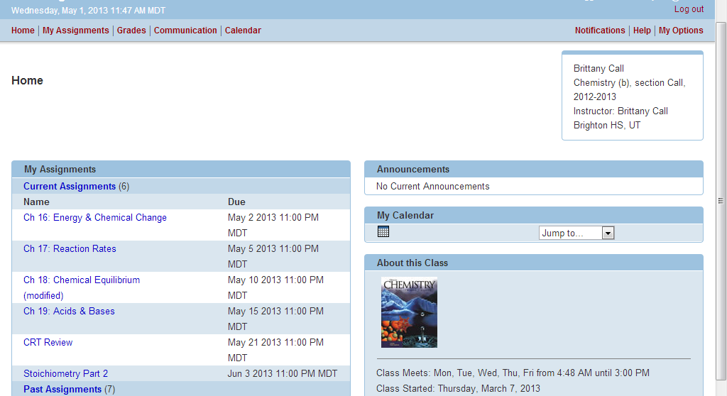
Assignments Due dates

Hints and helps are found at mmecall.weebly.com → Chemistry → Chemistry B → Current month → scroll to the very bottom to find hints and helps
Please let me know if you have questions!

