Today is a practice day! You are going to spend the day watching the Roman-Photo associated with this class. It’s like a mini-series. It’s cheesy, but hilarious and you will be surprised how much you know! As you go along, please complete as many activities as possible in your packet. This time is for THIS ACTIVITY ONLY. I have asked the sub to keep track of who is working and who is not – it will impact your participation grade. So, focus and have fun!

- Follow this link to access your book online: http://goo.gl/VNOXri

- In the upper right, put in the page number of the leçon that you are on
- Unité 1, Leçon 1A: Au Café (p.6)
- Unité 1, Leçon 1B: Les Copains (p.20)
- Unité 2, Leçon 2A: Trop de Devoirs (p.42)
- Unité 2, Leçon 2B: On Trouve une Solution (p.56)
- Unité 3, Leçon 3A: L’Album de Photo (p.78)
- Unité 3, Leçon 3B: On Travaille Chez Moi ! (p.92)
- Unité 4, Leçon 4A: Star du Cinéma (p.114)
- Unité 4, Leçon 4B: L’heure du Déjeuner (p.128)
- Unité 5, Leçon 5A: Au Parc (p.150)
- Unité 5, Leçon 5B: Quel Temps ! (p.164)
- Unité 6, Leçon 6A: Les Cadeaux (p.164)
- Unité 6, Leçon 6B: l’Anniversaire (p.186)
- Unité 7, Leçon 7A : De Retour au P’tit Bistrot (p. 222)

- Click the video button to watch the video

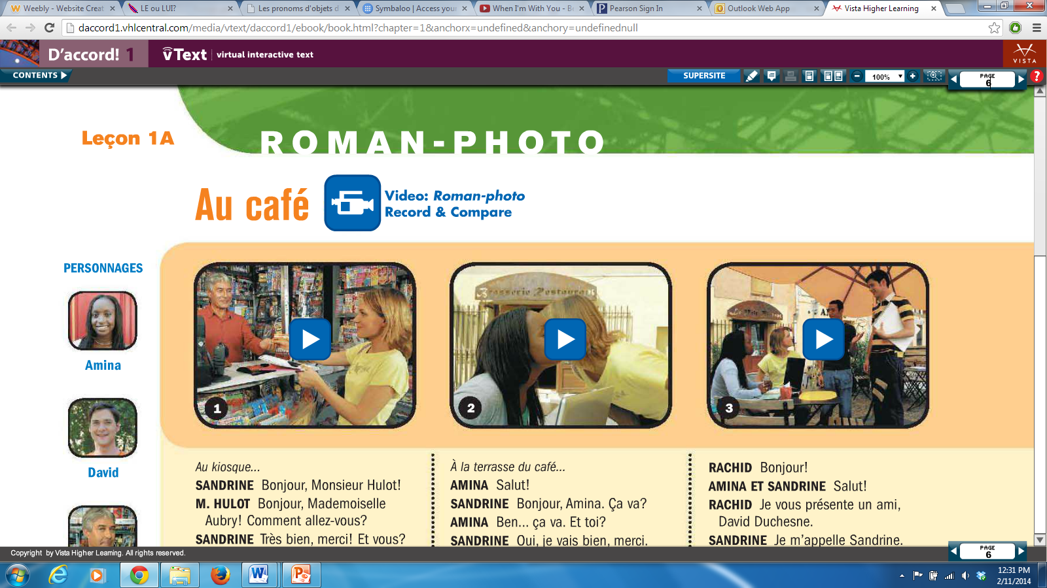

- Make sure headphones are in and working.

- Enjoy! Have fun and push yourself!

If you finish early… now you can study the vocabulary on quizlet.com

