` Using the words in the box, write 10 sentences on a separate sheet of paper to describe what Marc does during his week. Ex) Samedi matin, Marc et Julie regarde Sacre Coeur
demander échouer écouter enseigner expliquer trouver assister
préparer dîner passer téléphoner (à) visiter rentrer

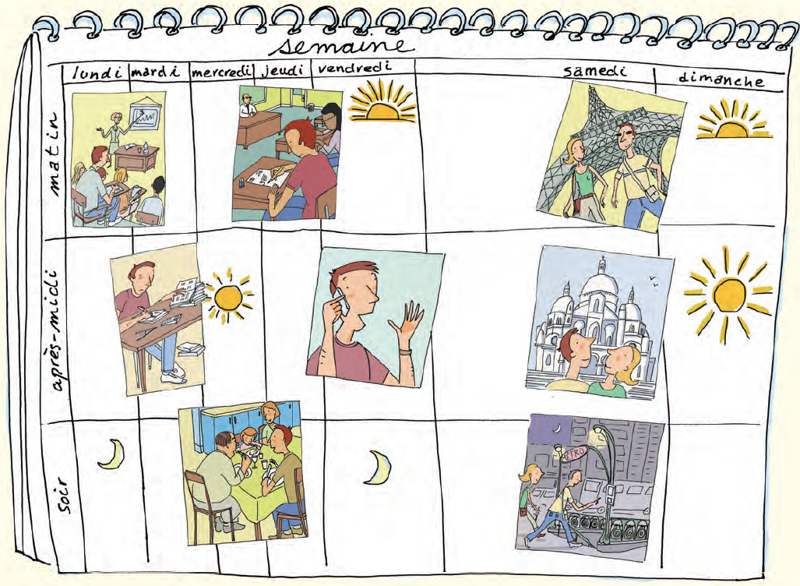

La semaine
 | lundi | mardi | mercredi | jeudi | vendredi | samedi | dimanche
Le matin
L’après-midi
Le soir

