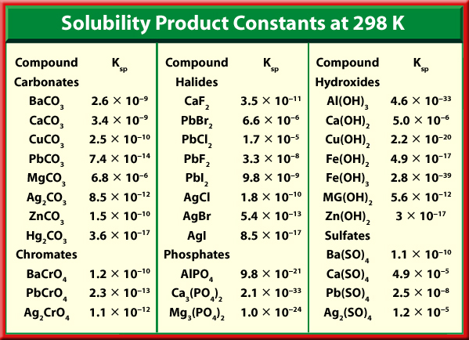

18.3 18a. Use Ksp to calculate [Ag⁺] in a solution of AgBr at equilibrium.

18b. Use Ksp to calculate [F⁻] in a solution of CaF₂ at equilibrium.

18c. Use Ksp to calculate the solubility of PbI₂

68. Calculate the molar solubility of strontium chromate (SrCrO₄) in water at 298 K if Ksp = 3.5x10⁻⁵

70. How many moles per liter of silver chloride will be in a saturated solution of AgCl? Ksp = 1.8x10⁻¹⁰

19c. Predict whether a will precipitate of Mg(OH)₂ will form when equal volumes of 0.20M MgCl₂(aq) and 0.0025M NaOH(aq) are mixed.

67. Calculate the ion product to determine what direction the equilibrium shifts & if a precipitate will form when 125mL of 0.005M sodium chloride is mixed with 125mL 0.001M silver nitrate solution.
NaCl(aq) + AgNO₃(aq) NaNO₃(aq) + AgCl(s)

69. Will a precipitate form when 1.00 L of 0.150M iron (II) chloride solution is mixed with 2.00 L of 0.0333M sodium hydroxide solution? What direction will equilibrium shift?

Ksp & Q KEY
18.3 18a) [Ag+] = 7.3x10⁻⁷ mol/L
18b) [F-] = 4.2x10⁻⁴ mol/L
18c) x = 1.3x10⁻³ mol/L
68. s = 5.9 x 10⁻³ mol/L
70. 1.3x10⁻⁵ mol/L
19c. A precipitate of Mg(OH)₂ forms
67. Qsp = 1.25x10⁻⁶; Ksp = 1.8x10⁻¹⁰ Qsp > Ksp,
equilibrium shifts to right, forms more products, and a precipitate forms
69. Qsp = 2.46x10⁻⁵; Ksp = 4.9x10⁻¹⁷ Qsp > Ksp,
equilibrium shifts to right, forms more products, and a precipitate forms

